**Week 10 Sessions 1 and 2 Lab**

**Using Selenium and Visual Studio to test websites**

**This lab should take you approx. 50 minutes**

# OBJECTIVES

* Learn about webdrivers
* Practice using the webdriver Selenium in Visual Studio

Selenium Web driver: <https://en.wikipedia.org/wiki/Selenium_(software)>

# *Selenium is a portable framework for testing web applications. Selenium provides a playback tool for authoring functional tests without the need to learn a test scripting language (Selenium IDE). It also provides a test domain-specific language (Selenese) to write tests in a number of popular programming languages, including C#, Groovy, Java, Perl, PHP, Python, Ruby and Scala. The tests can then run against most modern web browsers. Selenium runs on Windows, Linux, and macOS. It is open-source software released under the Apache License 2.0.*

# ACTIVITIES

1. The first step is to start Microsoft Visual Studio and create a new Visual C# Unit Test Project.

Once the solution opens right click on the Project file in the Solution Explorer Window and Select Manage Nuget Packages…

Conduct a search using Browse and the search term Selenium. The options for Selenium.WebDriver, Selenium.Support and Selenium.WebDriver.ChromeDriver should appear. Ensure you install these 3 packages to your project.

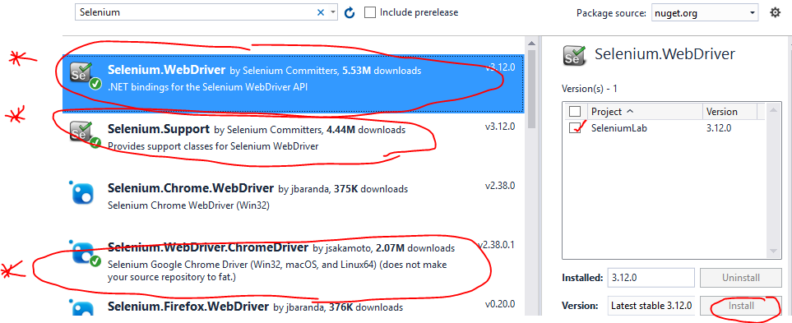

We will now create a test that opens a Chrome browser to Steam’s homepage and then clicks the login link to go to the login page.

Copy this code and run the test to see if it passes

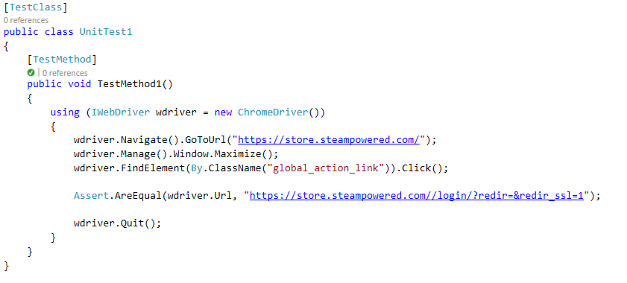

Simple tests like this are often referred to as “smoke tests” – just to test if anything breaks when you “turn it on”. Complete a suite of smoke tests (at least 3) to test basic navigation of a website of your choice. Take a snip of the code and test explorer and paste below.

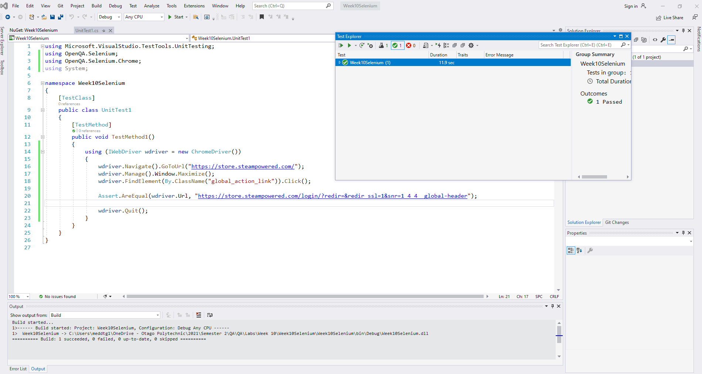

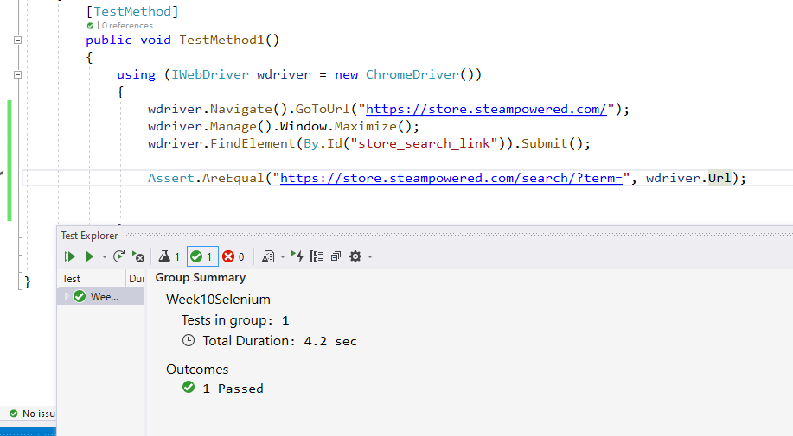

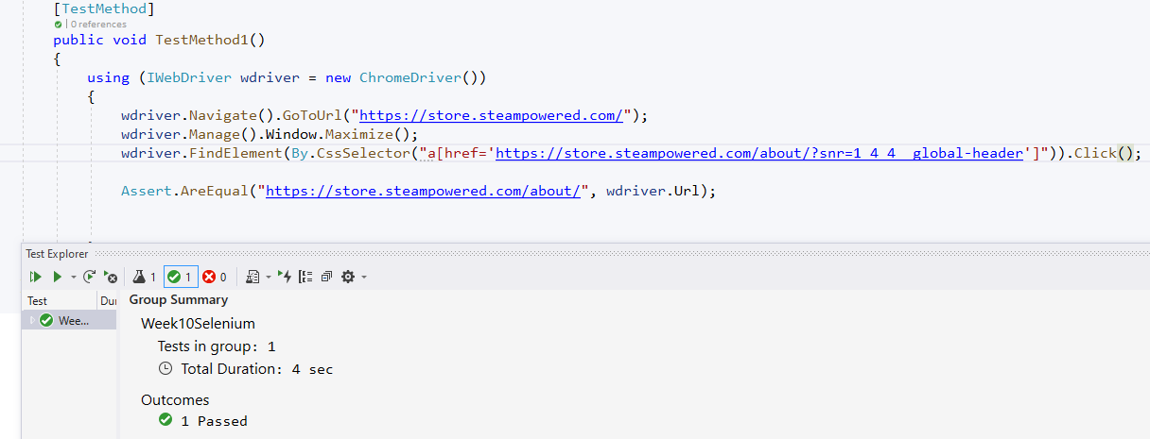

1. Create a new test that opens a Chrome browser and searches for “Otago Polytechnic”.

Hint: you will have to find the element on the webpage for the search box, then you can use the “SendKeys” method to input the search string. Finally, you will have to find the element for the search button and “click” it.

Add an assertion that the top result is “Otago Polytechnic”. Add a snip of your code and test result below.

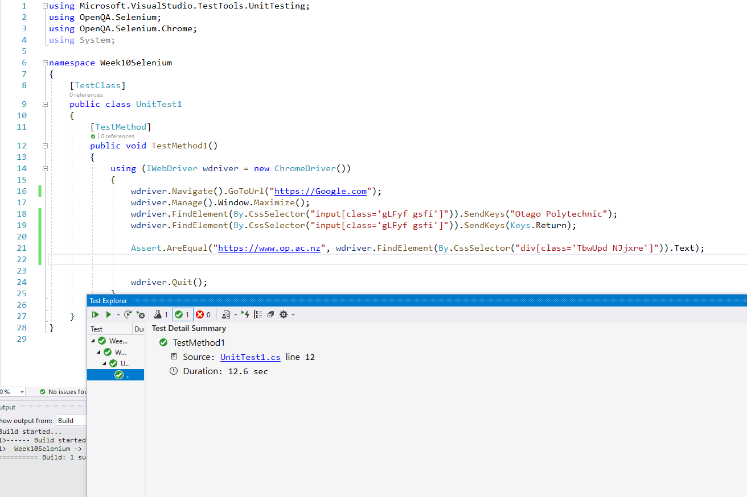

1. Create a new test that launches Chrome and goes to the ANZTB website. Make it navigate to the ISTQB Certified Testers List and confirm that my name is on the list of ISTB Certified Software Testers in Australia and New Zealand.

